Aim

Write a program to define the function template for calculating the square of given numbers with different data types.

Experiment - 28

Object Oriented Programming Lab

Syeda Reeha Quasar

14114802719

4C7

# **EXPERIMENT – 28**

## **Aim:**

Write a program to define the function template for calculating the square of given numbers with different data types.

## **Source Code:**

#include <iostream>

using namespace std;

template <class T>

inline T square(T x)

{

    T result;

    result = x * x;

    return result;

};

int main()

{

    int i, ii;

    float x, xx;

    double y, yy;

    i = 2;

    x = 2.2;

    y = 2.2;

    ii = square<int>(i);

    cout << i << ": " << ii << endl;

    xx = square<float>(x);

    cout << x << ": " << xx << endl;

    // Explicit use of template

    yy = square<double>(y);

    cout << y << ": " << yy << endl;

    // Implicit use of template

    yy = square(y);

    cout << y << ": " << yy << endl;

    return 0;

}

## **Output:**

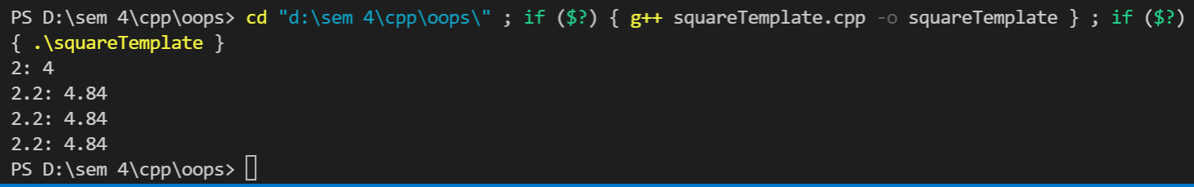

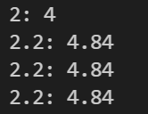

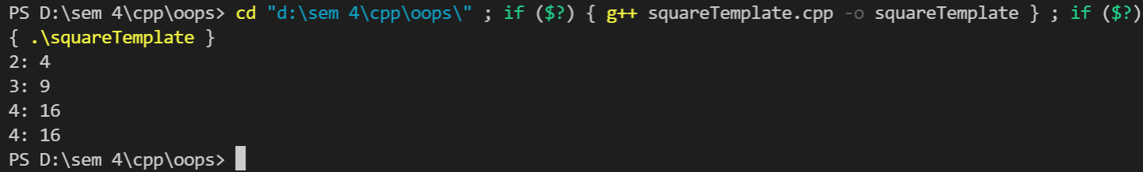

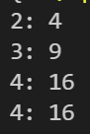

# **Viva Questions**

**Q1). What are templates in C++?**

Ans.

Templates are the foundation of generic programming, which involves writing code in a way that is independent of any particular type.

A template is a blueprint or formula for creating a generic class or a function. The library containers like iterators and algorithms are examples of generic programming and have been developed using template concept.

There is a single definition of each container, such as **vector**, but we can define many different kinds of vectors for example, **vector <int>** or **vector <string>**.

**Q2). How can templates be classified?**

Ans.

**Templates can be represented in two ways:**

* Function templates
* Class templates

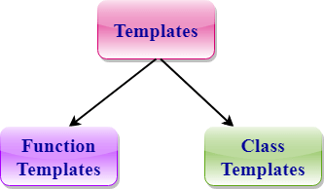

**Function Templates:**

We can define a template for a function. For example, if we have an add() function, we can create versions of the add function for adding the int, float or double type values.

**Class Template:**

We can define a template for a class. For example, a class template can be created for the array class that can accept the array of various types such as int array, float array or double array.

**Q3). Write about Function templates.**

Ans.

* C++ supports a powerful feature known as a template to implement the concept of generic programming.
* A template allows us to create a family of classes or family of functions to handle different data types.
* Template classes and functions eliminate the code duplication of different data types and thus makes the development easier and faster.
* Multiple parameters can be used in both class and function template.
* Template functions can also be overloaded.
* We can also use nontype arguments such as built-in or derived data types as template arguments.